**Assignment 10.5**

**Problem Statement :**

1.Write a pig script to find the top 20 destination people travel the most: Based on the given data

2. Write a pig script to find the top 20 locations from where people travel the most

**Input :**

You can download the dataset from the link below: Travel_Data

**Program :**

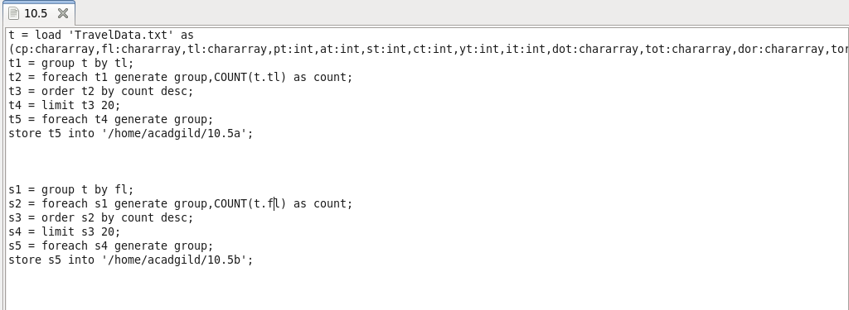

**Output :**

